JAVA

1. Uninstall old JAVA 6 version and reboot PC

2. Download JAVA 8 update 181 and install it

3. Open in Browser URL [*https://matrix-premium-ggdlx25p.logistics.corp*](https://matrix-premium-ggdlx25p.logistics.corp)

**

4. Click Webstart or client – WMS login window should appear

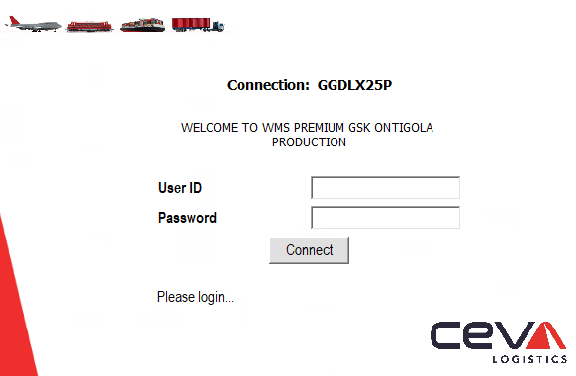

5. If you need to keep access to the legacy DLX you should use below alternative solution as described below

1. Download this java version from this url:: <http://cevamatrix.logistics.corp/SolutionAreas/WMS/3rd%20Party%20Applications/jre1.8.0_181.zip>
2. Unzip it to the folder “**X**:\Users\**usuario**\Documents\ -> ”X” is the hard disk unit where the user´s profiles is located, ”usuario” is the name of the user

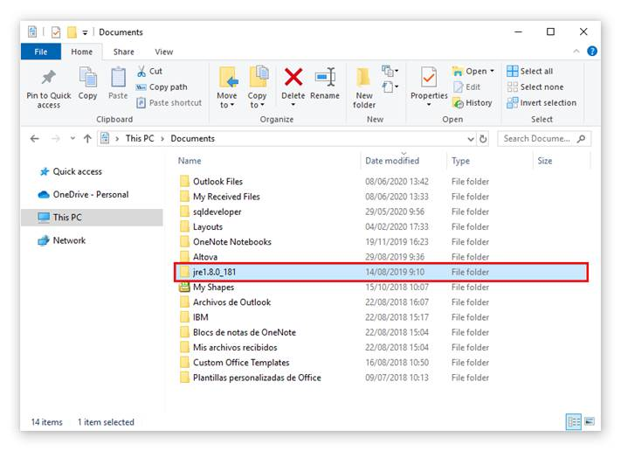

1. Create a shortcut in the desktop:

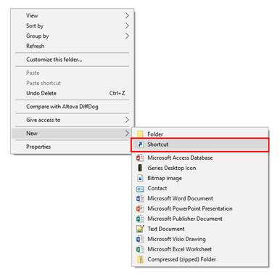

1. When the shortcut is created, right-click on it and fill in the following attributes:

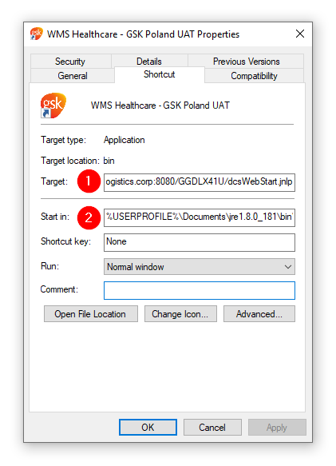

1. **d:\Users\agudod\Documents\jre1.8.0_181\bin\javaws.exe -Xmx256M http://glpdvlapp473.logistics.corp:8080/GGDLX25P/dcsWebStart.jnlp**

NOTE: Replace the path in red by the path in your laptop.

1. **%USERPROFILE%\Documents\jre1.8.0_181\bin\javaws.exe**

If when running the shortcut you get the following error:

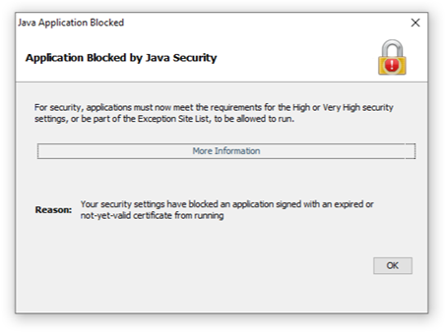

1. Go to the unzipped Java and open file ‘javacpl.exe’
2. Go to ‘Security à Edit site list’ and add the following: **http://glpdvlapp473.logistics.corp:8080**

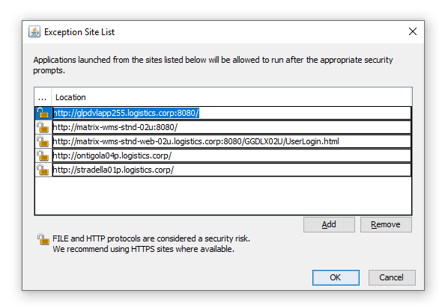

1. Confirm all windows and you are good to go.

IMPORTANT: Now, the link to access to the legacy DLX is the next:

<http://glpdvlapp241.logistics.corp/>

